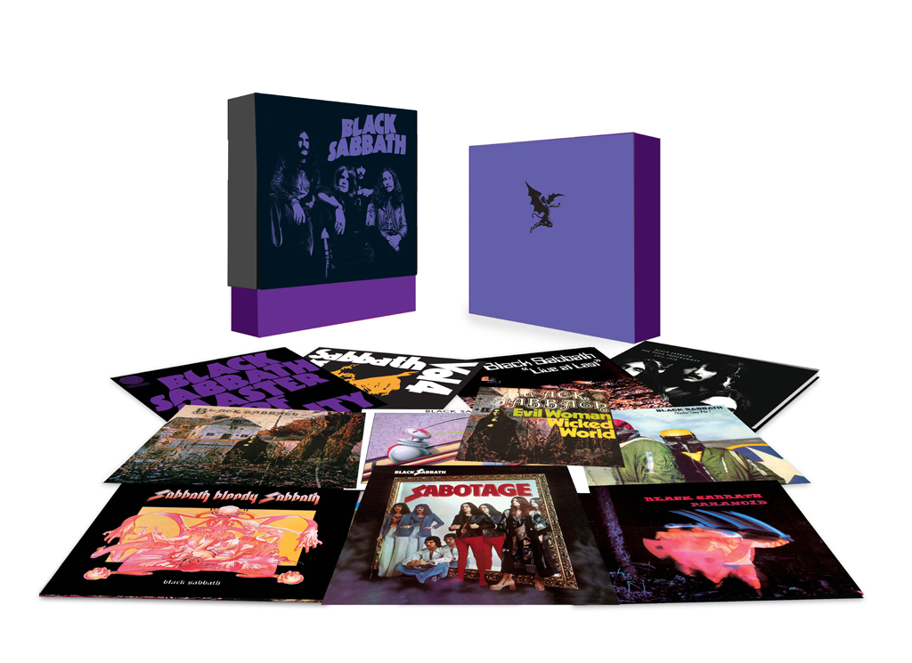**COMPUTER SCIENCE PRACTICAL FILE**

*PROJECT:* Music Store

*DONE BY:* Advaith Rajesh, Hrishikesh Kumar, Hritish Mahajan

*CLASS:* 12-I

**DELHI PRIVATE SCHOOL**

**SHARJAH**



DEPARTMENT OF COMPUTER SCIENCE

**CERTIFICATE**

Certified that the work in this file is the bonafide work of _____________________ of class XII _____ Roll Number ______________ recorded in the school labs during the academic year 2019 – 2020.

Date :_____________

_________________ ___________________

Teacher in charge External Examiner